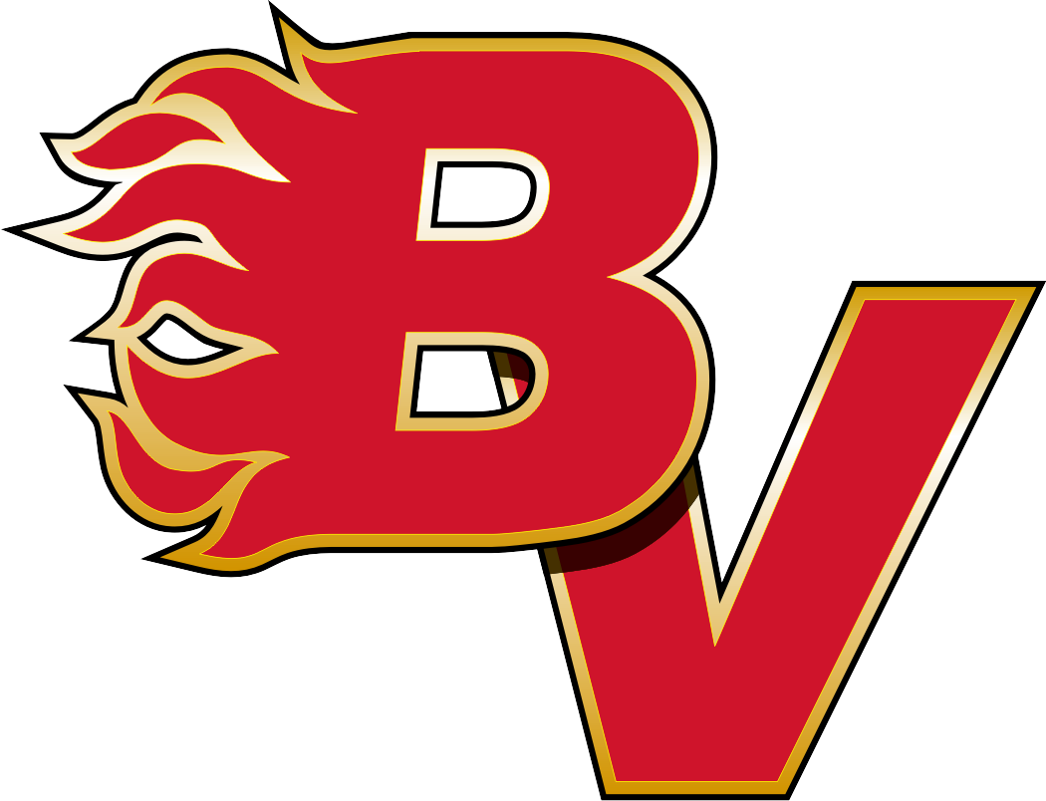BOW VALLEY HOCKEY SOCIETY
11150 Bonaventure Drive, S.E. Calgary Alberta
Office: 403-225-8564
T2J 6R9

(Date)

To Whom It May Concern,

We are families from the Bow Valley Hockey Society and we are requesting permission to sell raffle tickets outside your place of business. The prize of the Bow Valley Hockey Society 2018 raffle is a 2018 Jeep Grand Cherokee.

This raffle is a major fundraiser for Bow Valley Hockey with the proceeds going toward the day-to-day operation of our minor hockey program.

There are over 1,000 girls and boys who participate in Bow Valley Hockey. Each year the families of these young hockey players work together to sell raffle tickets to raise money to help our association maintain excellent value at a reasonable cost. This in turn helps to make minor hockey accessible to families in our community.

Thank you for supporting the Bow Valley Hockey Society.

Regards,

(Your Name, Team Name)

